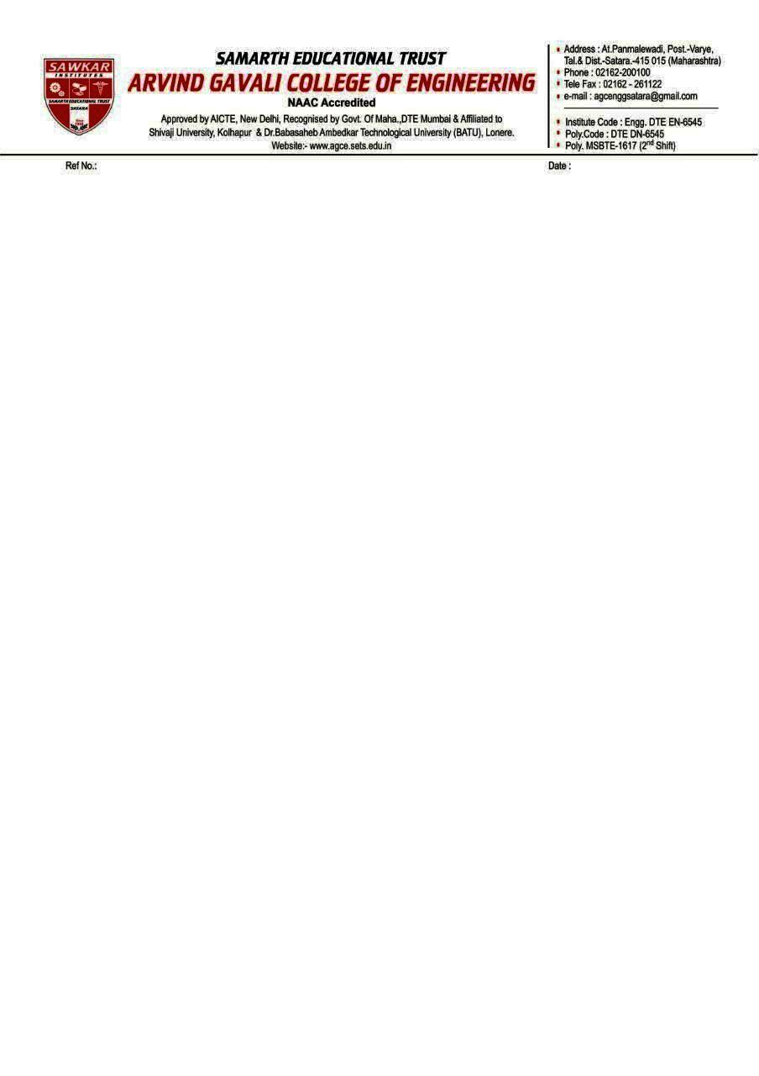

**Date: - 29/02/2024**

**NOTICE**

**Even SEM 2023-24**

**Theory and Practical CA-1 Exam. (Objective & Descriptive)**

* **Theory CA-1 Examination is scheduled from 4th March 2024 to 9th March 2024.**
* **Theory CA-1 Exam. Marks -10 Marks**
* **Objective exam will be conducted through online mode via ERP Exam is MCQ based on CO-1 & CO-2, Total Questions: 20 (Unit 1:10 MCQ , Unit 2:10MCQ ) Time 10 Min Total Marks:-10**
* **CA-1 Exam. Descriptive will be conducted on offline mode Daily papers exam is of 10 Marks based on CO-1 and CO-2 Time: 30 min.**
* **Respective Subject Teacher has to Submit Assignment 1 & 2 on ERP.**
* **Respective Subject Teacher has to Submit 3 sets of Theory CA-1 Exam. Question Paper in examination department**
* **CA-1 Practical Exam. will be conducted on offline mode Daily Practical batches as per academic time table Practical CA-exam is of 15 Marks based on 5 Experiment**

**Principal**

**Dr. Vilas Pharande**