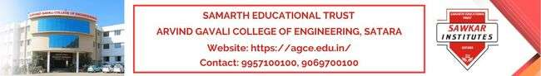

ELECTRONIKA - ACADEMIC YEAR 2022-2023
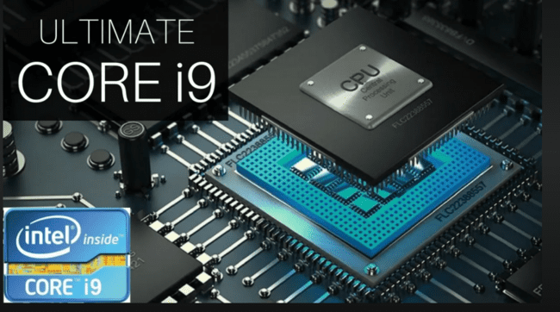
Department of Electronics and Telecommunication Engineering, Satara.

INSTITUTIONAL VISION, MISSION, CORE VALUES & PO’S

Our Vision
- To be an institute of excellence, developing skilled engineers to serve the industry and society.

Our Mission
- M1. To provide quality education through effective teaching learning process.
- M2. To develop professional skills and promote innovation among students by providing a conducive Atmosphere.
- M3. To inculcate ethical values, respect for the environment, and social responsibility.

Institute Core Values:
- Professional Ethics
- Excellence
- Social Responsibility
- Accountability & Transparency
- Use of Technology

Program Outcomes (POs)

PO1. Engineering knowledge: Apply the knowledge of mathematics, science,
engineering fundamentals, and an engineering specialization to the solution of complex
engineering problems.
PO2. Problem analysis: Identify, formulate, review research literature, and analyse complex
engineering problems reaching substantiated conclusions using first principles of mathematics,
natural sciences, and engineering sciences.
PO3. Design/development of solutions: Design solutions for complex engineering problems
and design system components or processes that meet the specified needs with appropriate
consideration for the public health and safety, and the cultural, societal, and environmental
considerations
PO4. Conduct investigations of complex problems: Use research-based knowledge and
research methods including design of experiments, analysis and interpretation of data, and
synthesis of the information to provide valid conclusions
PO5. Modern tool usage: Create, select, and apply appropriate techniques, resources,
and modern engineering and IT tools including prediction and modelling to complex engineering
activities with an understanding of the limitations.
PO6. The engineer and society: Apply reasoning informed by the contextual knowledge
to assess societal, health, safety, legal and cultural issues and the consequent responsibilities
relevant to the professional engineering practice.

PO7. Environment and sustainability: Understand the impact of the professional engineering
solutions in societal and environmental contexts, and demonstrate the knowledge of, and
need for sustainable development.
PO8. Ethics: Apply ethical principles and commit to professional ethics and responsibilities
and norms of the engineering practice.
PO9. Individual and team work: Function effectively as an individual, and as a member
or leader in diverse teams, and in multidisciplinary settings.
PO10. Communication: Communicate effectively on complex engineering activities with the
engineering community and with society at large, such as, being able to comprehend and write
effective reports and design documentation, make effective presentations, and give and receive
clear instructions.
PO11. Project management and finance: Demonstrate knowledge and understanding
of the engineering and management principles and apply these to one’s own work, as a member
and leader in a team, to manage projects and in multidisciplinary environments.
PO12. Life-long learning: Recognize the need for, and have the preparation and ability to
engage in independent and life-long learning in the broadest context of technological change.

DEPARTMENTAL VISION, MISSION & PEO
Vision
- To be one of the leading electronics and telecommunication engineering department engage in quality education to solve industrial and social problems.
Mission
The department is committed to imbibe and empower its faculty and aspiring engineers with:
- M1: To enrich academic competency by imparting quality education.
- M2: To nurture skills among the students helping them succeed and progress in their personal and professional career.
- M3: To instil sensitivity towards society and respect for the environment.

Program Educational Objectives (PEOs)
- PEO1: The graduates will be able to apply the basic concepts of mathematics, sciences, engineering to solve industrial and societal problems.
- PEO2: The graduates will be able to deal with complex real time problems by applying technical and soft skills.
- PEO3: The graduates will be able to develop awareness towards ethical, societal & environmental issues.

Program Specific Outcomes (PSOs)
- PSO1: Students will be able to analyze and design the electronics and telecommunication systems by understanding and applying the fundamental knowledge.
- PSO2: Electronics and telecommunication students will be able to contribute to projects in the core and associated domain by using modern tools like PCB design, embedded programming, etc.

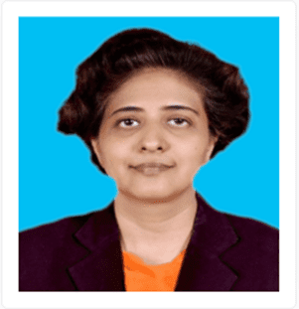
Kudos

Name: Dr. Gayatri Shashikant Mirajkar
- Designation: Professor
- Qualification: Ph. D (Electronics Engg.)
- Area of Expertise: Electronics, Digital signal processing
- Experience: 16 years 2 months
- Phone: 9860361553
- Email ID: gayatrimirajkar@gmail.com
- Dr. Gayatri S. Mirajkar invited as speaker on Image Processing in Toxicology: A review in International Summit on Toxicology and Applied Pharmacology April 27-28, 2023 at Valencia, Spain.
- She also has been elected member of Board of Examinations DBATU Lonere 2023.
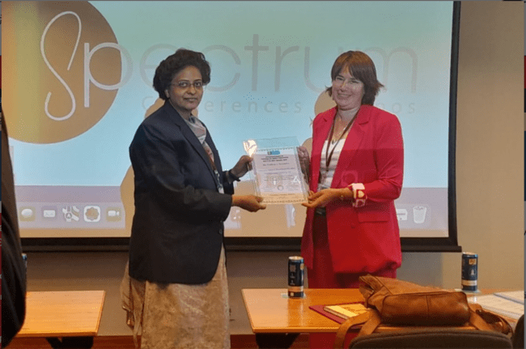

Students’ Achievements

Gouri Kenjale

NPTEL Online Certification

In Introduction to Internet of Things

Secured 65 %

Vaishnavi Mahangade

NPTEL Online Certification

In Soft Skills Secured 58 %

Pratiksha Channe

Competition Name: Project Competition “Spectrum 2K22” at DACOE, Karad

Date: 20 May 2022

Secured First Place

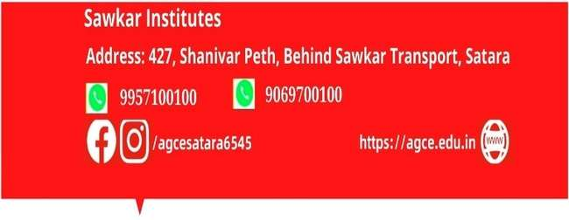

Students’ Achievements

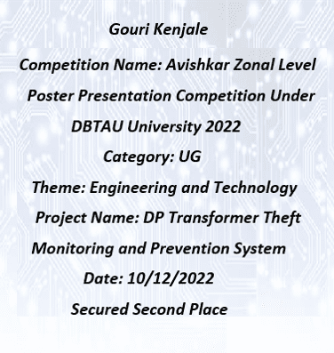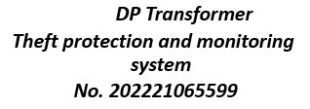

Students’ Achievements

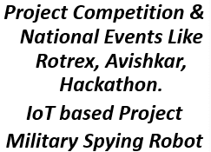
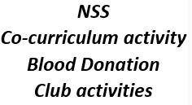

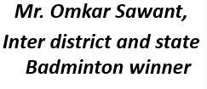

Best Practices of The Department

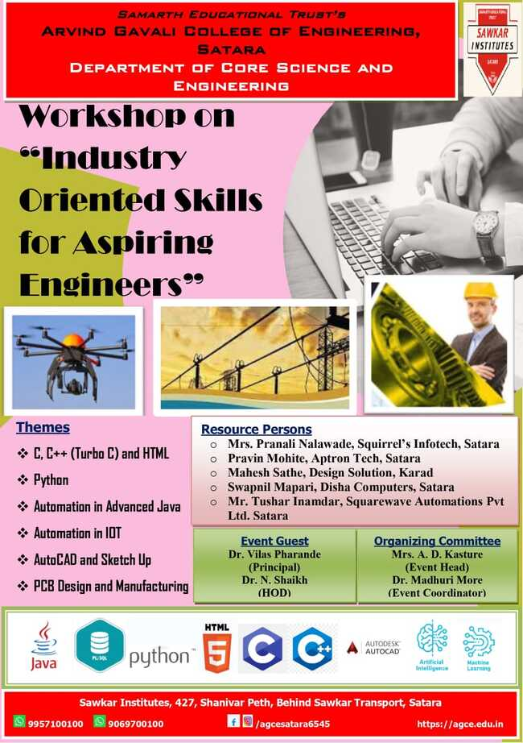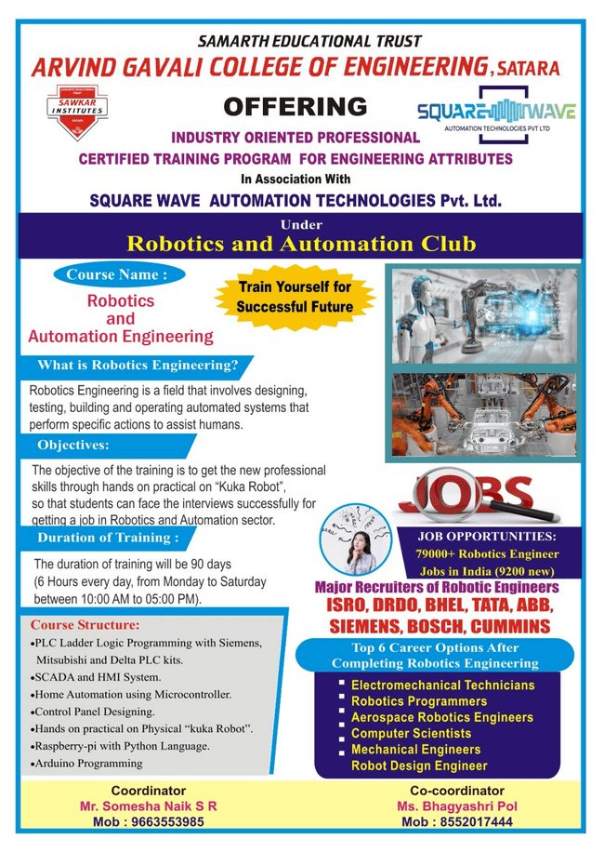

Skill development through Hands on Workshop

Best Practices of The Department
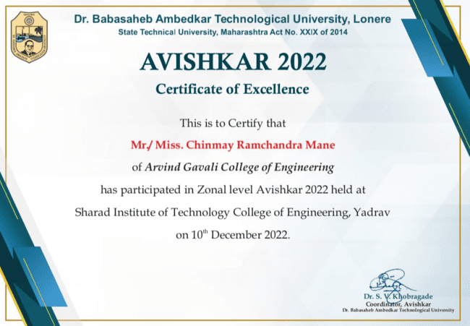

Achievements through project competitions
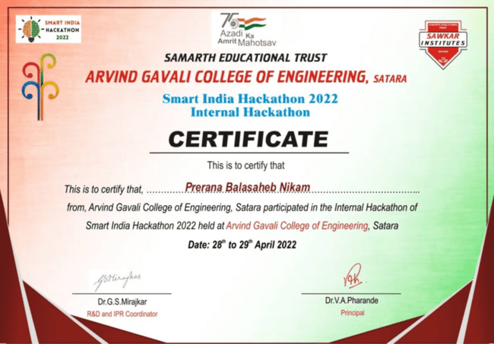

PLACEMENT TALKS and CONNECTS:

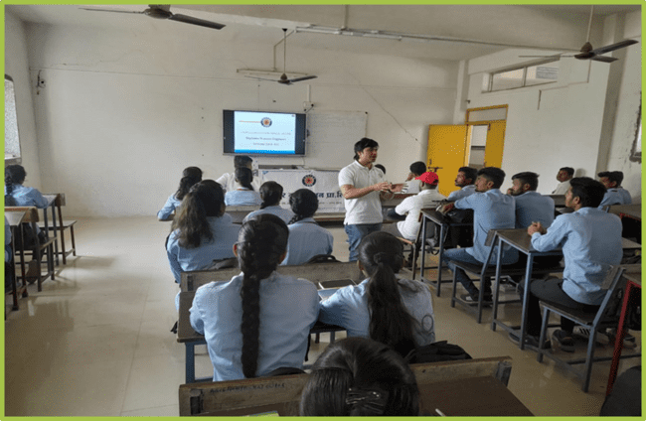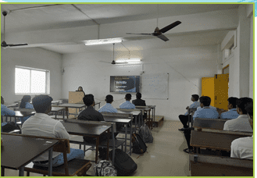

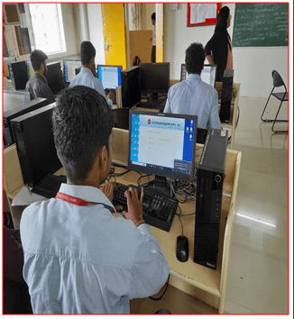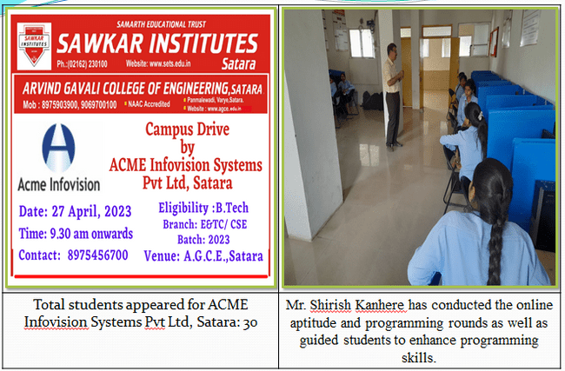

PLACEMENT TALKS and CONNECTS:

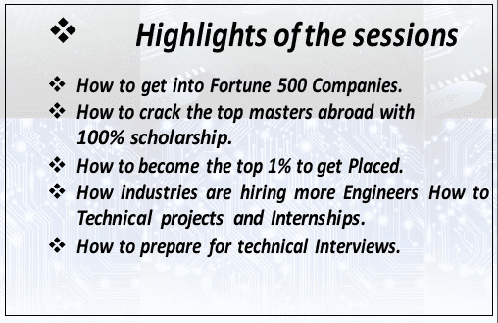
Company Name | Profile Detail | Package Detail
KPIT Technologies Ltd., Pune | Software Engineer | Rs. 9.450 Lakhs p.a
Infosys | Developer | Rs. 4 Lakhs p.a
Accenture | Process Engineer | Rs. 5.6Lakhs p.a.
TCS | System Engineer | Rs. 3.5 Lakhs p.a
TATA Communication Transformation Services Ltd. Pune | Associate Engineer | Rs. 2.8 Lakhs p.a
Team Leas | Network Design Optimization Engineer | Rs. 3.2 Lakhs p.a
PHILIPS | Trainee Engineer | Rs. 3.8 Lakhs p.a

Placements Activities:

Co-curricular Activities

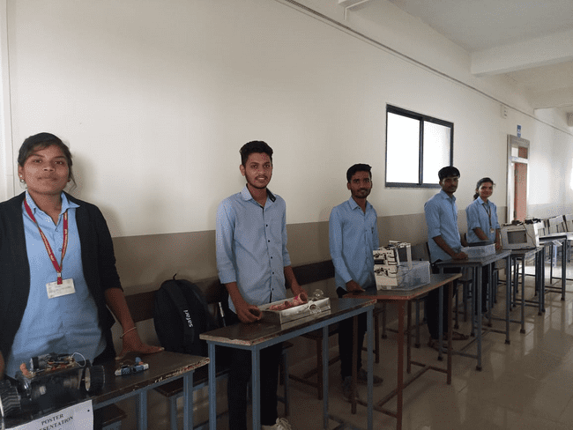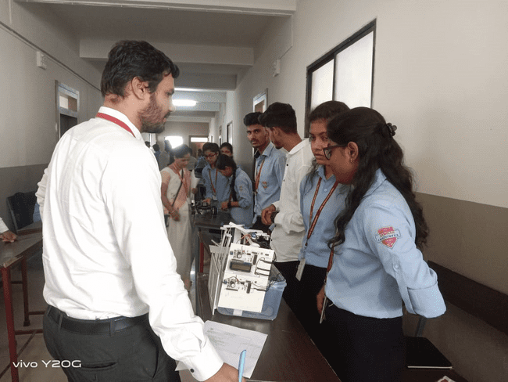

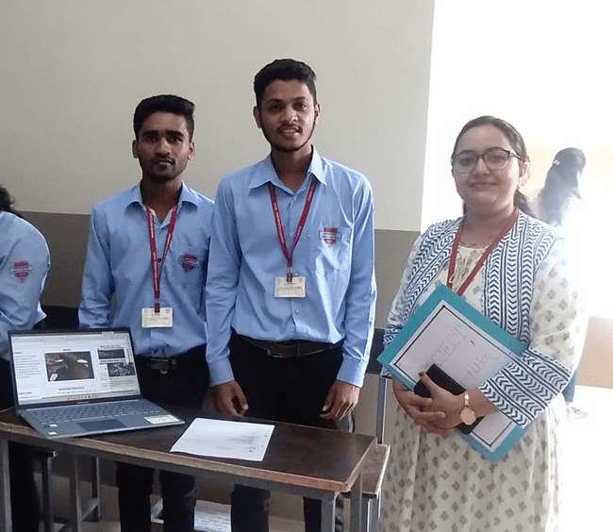

Project competition on Independence Day

Co-curricular Activities

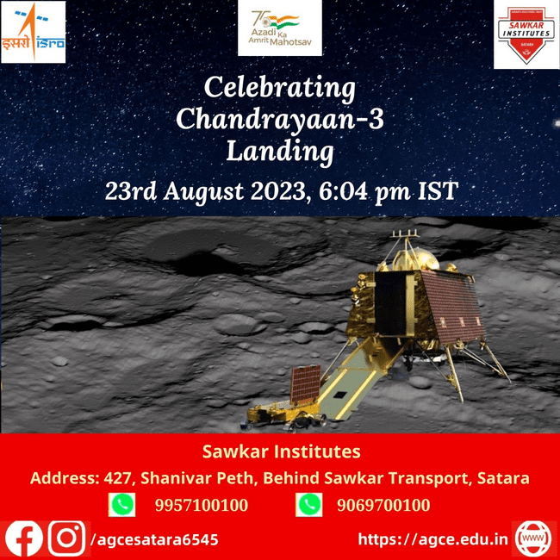

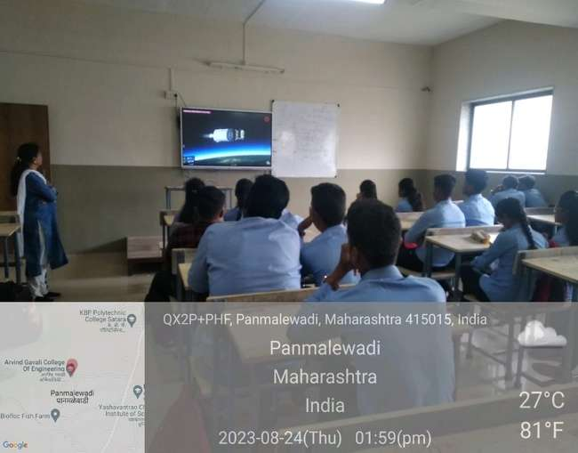
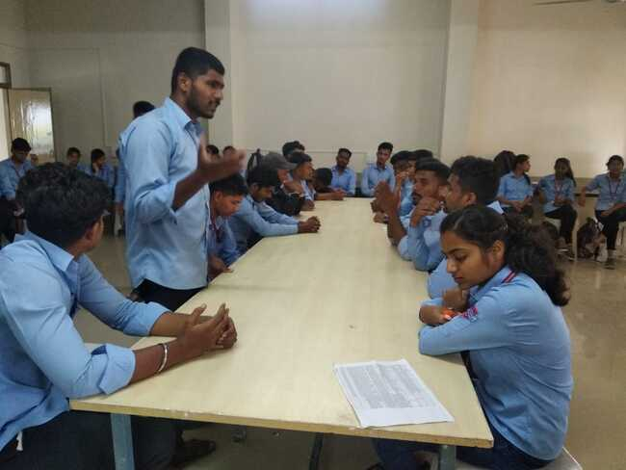

Chandrayaan -3 Launching and Landing Debate Competition
Demonstration for Students

Extra-curricular events

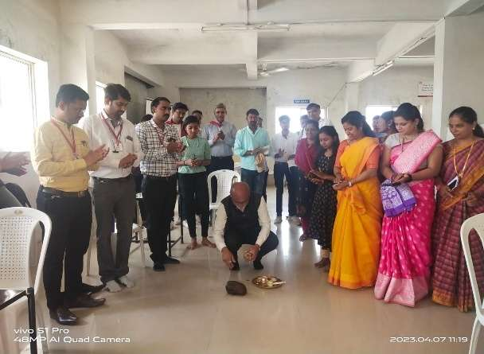

Inoguration by Principal Mr. Pharande Ceremony of extra curricular

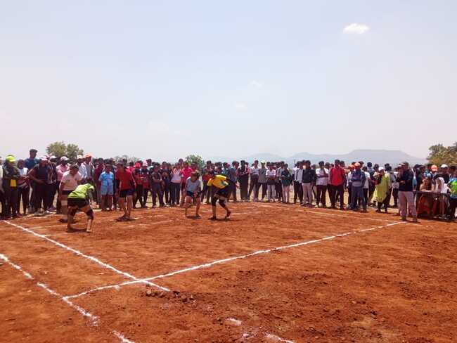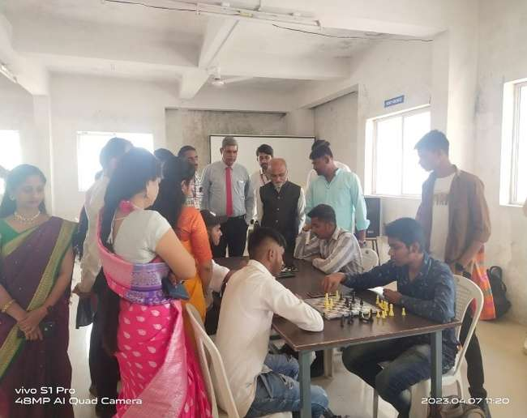

Kabbaddi Chess

Faculty Development Program
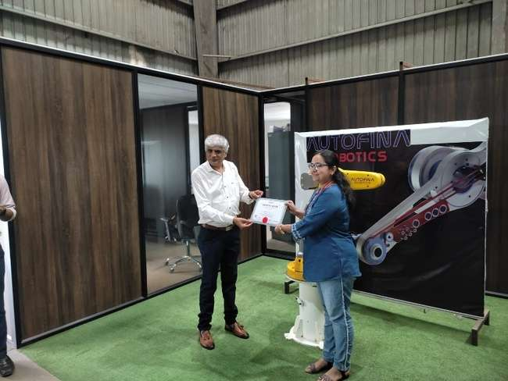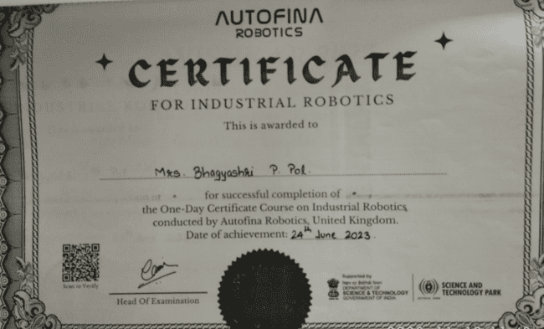
Issuance of Certificate to Asst. Prof. Mrs. Pol B. P. by Mr. Parekh Director of Autofina Robotics, Talegaon Pune

Parent Meet
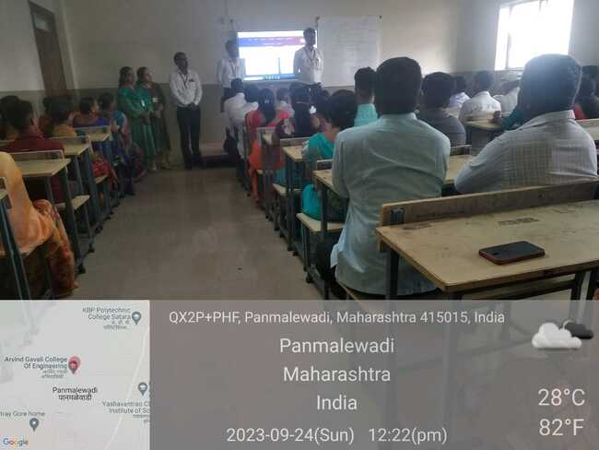

Interaction with Parents by E&TC faculty

Extra-curricular events

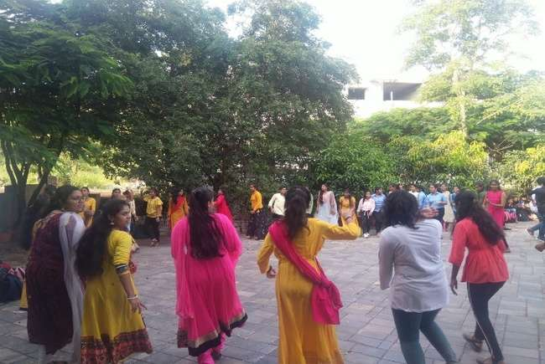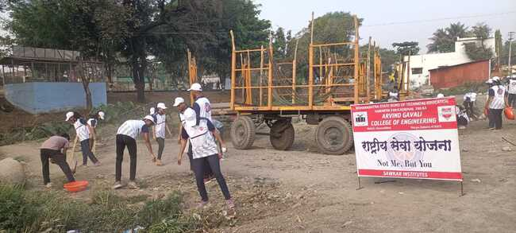

Celebration of Days NSS Activity

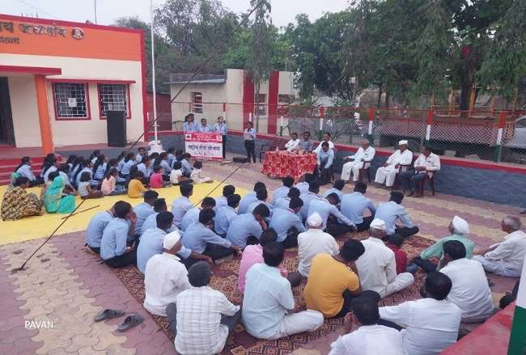

Janjagruti Program Conducted under NSS camp

.

Publications
SCI-Indexed PUBLICATIONS

